Demonstrate the tas 2;

Producer
- Butter first wait for the empty slot if the buffer is full it will stops
- As it find the slot I will lock the buffer so that any other buffer will not interface btw them
- Producer puts the item in the buffer and shift the in index to the next position
- Then unlock the buffer and the signal the consumer is the new item is ready
Consumer
Consumer wait for the full slot
Lock the buffer and the exit the items
Moves the out index forward and then unlocks the buffer
Signal the producter that the one lot is free

Task 1
Code

#include <stdio.h>
#include <pthread.h>
#include <semaphore.h>
#include <unistd.h>
sem_t parking_spaces;
void *car(void *arg)
{
int id = *(int *)arg;
printf("Car %d is trying to park...\n", id);
sem_wait(&parking_spaces); // Try to get a space
printf("Car %d parked successfully!\n", id);
sleep(2); // Stay parked for 2 seconds
printf("Car %d is leaving.\n", id);
sem_post(&parking_spaces); // Free the space
return NULL;
}
int main()
{
pthread_t cars[10];
int ids[10];
// Initialize: 3 parking spaces available
sem_init(&parking_spaces, 0, 3);
// Create 10 cars (more than spaces!)
for (int i = 0; i < 10; i++)
{
ids[i] = i + 1;
pthread_create(&cars[i], NULL, car, &ids[i]);
}
// Wait for all cars
for (int i = 0; i < 10; i++)
{
pthread_join(cars[i], NULL);
}
sem_destroy(&parking_spaces);
return 0;
}

Output

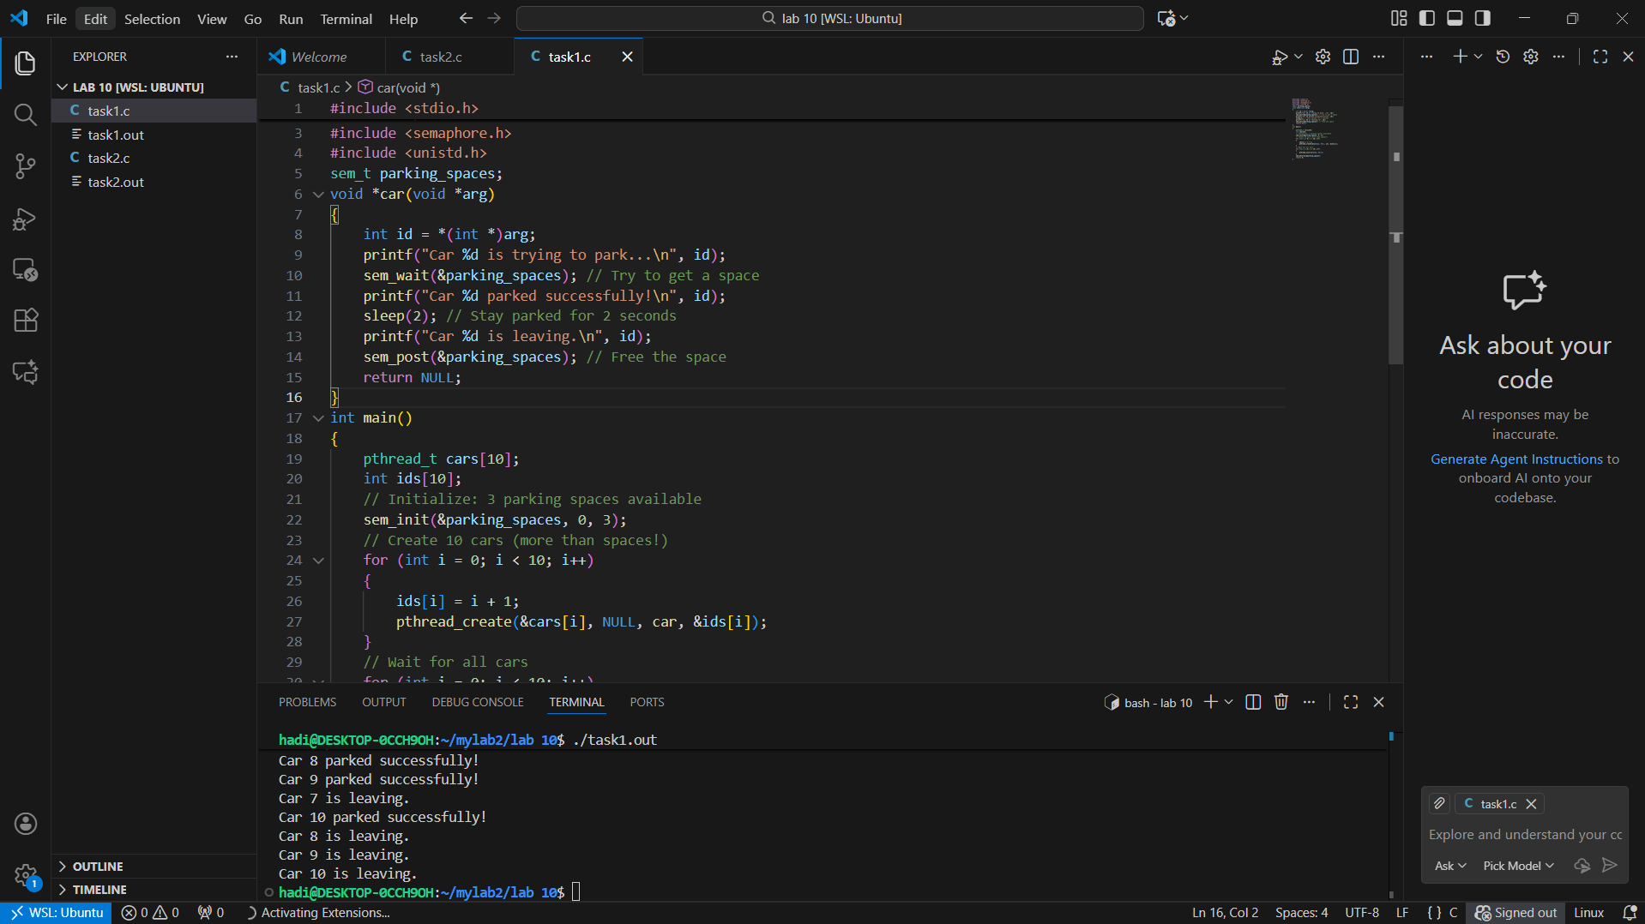

Task 2

Code

#include <stdio.h>
#include <pthread.h>
#include <semaphore.h>
#include <unistd.h>
#define BUFFER_SIZE 5
int buffer[BUFFER_SIZE];
int in = 0; // Producer index
int out = 0; // Consumer index
sem_t empty; // Counts empty slots
sem_t full; // Counts full slots
pthread_mutex_t mutex;
void *producer(void *arg)
{
int id = *(int *)arg;
for (int i = 0; i < 3; i++)
{ // Each producer makes 3 items
int item = id * 100 + i;
// TODO: Wait for empty slot
sem_wait(&empty);
// TODO: Lock the buffer
pthread_mutex_lock(&mutex);
// Add item to buffer
buffer[in] = item;
printf("Producer %d produced item %d at position %d\n",
id, item, in);
in = (in + 1) % BUFFER_SIZE;
// TODO: Unlock the buffer
pthread_mutex_unlock(&mutex);
// TODO: Signal that buffer has a full slot
sem_post(&full);
sleep(1);
}
return NULL;
}
void *consumer(void *arg)
{
int id = *(int *)arg;
for (int i = 0; i < 3; i++)
{
// TODO: Students complete this similar to producer
sem_wait(&full);
pthread_mutex_lock(&mutex);
int item = buffer[out];
printf("Consumer %d consumed item %d from position %d\n",
id, item, out);
out = (out + 1) % BUFFER_SIZE;
pthread_mutex_unlock(&mutex);
sem_post(&empty);
sleep(2); // Consumers are slower
}
return NULL;
}
int main()
{
pthread_t prod[2], cons[2];
int ids[2] = {1, 2};
// Initialize semaphores
sem_init(&empty, 0, BUFFER_SIZE); // All slots empty initially
sem_init(&full, 0, 0); // No slots full initially
pthread_mutex_init(&mutex, NULL);
// Create producers and consumers
for (int i = 0; i < 2; i++)
{
pthread_create(&prod[i], NULL, producer, &ids[i]);
pthread_create(&cons[i], NULL, consumer, &ids[i]);
}
// Wait for completion
for (int i = 0; i < 2; i++)
{
pthread_join(prod[i], NULL);
pthread_join(cons[i], NULL);
}
// Cleanup
sem_destroy(&empty);
sem_destroy(&full);
pthread_mutex_destroy(&mutex);
return 0;
}
Output
